Patient Health Record Intake Workflow

Cara A. Garcia

University of Mary

NUR 667 Applied Clinical Informatics in Patient Centered Care

Shawn Ehler

August 6, 2023

Patient Health Record Intake Workflow
The patient health record (PHR) is a physical or electronic record of a patient’s pertinent medical history that is recorded, prioritized, and in all other ways managed by the patient or their caregiver. Unlike an electronic health record (EHR) which is managed by a provider or a health organization, the PHR represents a collection of information from any or all healthcare encounters deemed important to the patient, making it easier for them to share and manage their health data. The benefits of such a record include increased patient engagement (PE), safety against interoperability issues when seeing providers outside the patient’s usual health system, and easy access to records (Alsahafi & Gay, 2018). Despite the advantages to having a PHR, many organizations have not yet created a viable method for their inclusion within the EHR. This paper will examine the current use of PHRs, a current state intake workflow analysis of an ambulatory clinic, and a future workflow plan based on that analysis and pertinent research.
Current Use of Personal Health Records

Value of PHR
The value of PHRs has been recognized throughout healthcare literature. One of the first studies to look at the fiscal benefits was by Kaelber and Pan (2008), who reported that initial start-up costs aside, PHRs could offer organizations billions in cost savings. The findings of Ruhi and Chugh (2021) also highlighted financial benefits to organizations related to increased efficiency and the ability to avoid duplicative tests as patients can share results from specialists with their primary provider. The integration of patient-generated health data (PGHD) int the EHR is a formidable goal of the Agency for Healthcare Research and Quality (AHRQ). According to the AHRQ (n.d.a) studies are currently underway to explore ways in which data can be incorporated into the EHR, adding important information for more thorough clinical decision making.
PGHD Efficiencies
Efficiencies made possible by PGHD collection are largely around the capturing of data from multiple patient sources such as wearables, and other remote-monitoring devices. According to Walker et al. (2017), PHR’s “are a central component of PE, particularly for patients attempting to self-manage chronic conditions because they allow patients to input and track health information” (para. 2). Hussein et al. (2021) praised the collection and use of remote-monitoring data for its ability to provide color to an otherwise black and white condition. Other efficiencies include the ability to receive faster interventions. For example, a provider noting an upward trend in blood pressure as demonstrated by PGHD could increase a patient’s dose of blood pressure medication instead of the patient having to wait for an upcoming appointment.
Patient Engagement
According to Walker et al. (2017), PHR’s “are a central component of PE, particularly for patients attempting to self-manage chronic conditions because they allow patients to input and track health information” (para. 2). Technology can be developed to empower patients to monitor and manage their conditions, resulting in higher PE. Educating a patient on the importance of stress reduction is beneficial, but offering them a digital stress diary may have a more profound impact. Similarly, a patient’s ability to communicate with their provider more often and with greater ease strengthens the PE (Walker et al., 2017). Lordon et al. (2020) found that when PHR design was optimal, sharing PGHD with providers supported a collaborative relationship and enhanced PE.
Barriers to PGHD
Barriers to PGHD can be from the perspective of the provider, the patient, or the technological limitations. Hussein et al. (2021) found that of patient fears, those related to information security was paramount, though both patients and providers worried over reimbursement costs. Provider concerns surrounded information overload, and provider uncertainty with how to process information that may be outside of their area of expertise. Technical barriers to PGHD remain interoperability failures and a lack of convention with regard to what and how much data to capture (Hussein et al. 2021). Another barrier to PGHD is related to health equity, as not every patient has the same access to remote monitoring tools, or has the mental, emotional, or physical ability to manage a PHR (AHRQ, 2021).
Current State Workflow Analysis
The clinical area that was chosen for a current state workflow analysis was a multi-specialty suite in a medical plaza across from a hospital; see Appendix A for a process map of the current state workflow. The individuals in the workflow included front office staff (FOS), medical assistants (MA)’s that served the back office areas, and advanced practice providers (APP)’s. Linear key steps in the workflow included patient check-in with FOS in the lobby, the patient being greeted by the MA and escorted to the back office area, the measurement of patient vital signs by the MA, patient rooming by the MA, basic health status and vital signs documentation by the MA, the patient’s visit with the APP, and the patient’s return to the lobby via MA escort, so that the next appointment could be scheduled by the FOS.
Decision points of note were if the patient was new, or any of an established patient’s information was new, which required patient interaction and adjustment by the FOS. Another decision point near the end of the visit occurred when the APP needed to determine if the patient was ready for discharge, or if the MA needed to perform closing procedures or tasks prior to discharge.
Tools utilized were paper documents by FOS, and a computer to manually enter demographics and financial information about the patient as needed. A card scanner was ready so that FOS could scan patient identification and insurance information into Epic. Technology utilized included a vital signs machine in the back-office area, and a thin client loaded with Epic software inside the exam room. Room status lights were used to flag providers and back-office staff of the need for the MA or APP to present to the patient’s exam room. A printer in the back-office area was utilized to create a paper after visit summary (AVS) that the MA could give to the patient upon discharge. Once the patient was escorted back to the lobby, the FOS used computers to schedule any follow up visits. Tools utilized included a cash bag to collect copays or any incidental fees. FOS documented the receipt of any payments in their computer.
The greatest inefficiency noted during assessment was the use of in-person visits that could have been virtual. The site I visited does participate in telemedicine, but there is a lot more opportunity for remote visits. In terms of in-person workflow, most of the inefficiencies were related to staff-dependent manual processes that could be automated in a multitude of ways. The need for a team of FOS seemed like an obvious area for improvement. Switching check-in procedures from FOS to an electronic check in process would be a good start. For patients that are unable to check in via the patient portal, an alternative automated check-in process could be utilized, a concept that will be expanded on shortly.
Medical assistants taking every patient’s vitals before every appointment also seems superfluous, especially given the potential use of PGHD. Unless there are extenuating circumstances, MA’s should not have to perform a great deal of charting, which they currently do. Much of the information they collect could be completed by the patient via their portal, prior to the in-person visit. Having to log into the EHR manually seems outdated, especially since biometrics are more efficient and more secure than usernames and passwords (Hebda et al, 2019). Having to print an AVS also seems unnecessary.
Finally, escorting the patient to the lobby for another encounter with the FOS could be eliminated. Follow-up appointments could be scheduled via the patient portal, and the collection of fees could be reimagined. This would require some healthcare organizations (HCOs) to redesign some of their outdated key performance indicators (KPI)’s like the goal of collecting copays before the patient leaves. This KPI could instead be shifted to a goal of automatic copay collection prior to the visit via the patient portal. Even parking validation could easily be automated.
Future State Workflow Planning
When designing the future state workflow, the first change was to reduce the number of tasks completed inside the clinic; see Appendix B for a process map of the future state workflow. The goal was to create a “smart clinic”, and off-campus activities were designed with the personal health record in mind. Care was taken to plan for patients that are new to a smart clinic or established patients who are having technological issues that need to be addressed by IT. The workflow begins with a patient calling to make an appointment. An established patient will trigger a quick analysis to assure that PGHD is flowing into the EHR. A new patient calling for an appointment will trigger the transfer of the call to a triage nurse that will assess the patient's medical urgency, as well as technology-related needs. If the need for a visit is urgent, the triage nurse will arrange for the patient to be seen in urgent care emergency department. If the visit is not urgent, the triage nurse will perform an E-literacy and health-literacy assessment.
Using an 18-item questionnaire like the short assessment of health literacy- English (SAHL-e), the triage nurse will rank the patient much like they would per the interviewer instructions provided by the AHRQ. According to their tool, scoring fewer than 14 points would indicate low health literacy (AHRQ, n.d.b). If the patient has a score of less than 14 on health literacy, the appointment time will be longer; more to come on this. Let’s imagine that a similar questionnaire, this one measuring technological abilities, is available. The triage nurse will ask another 18 questions around technology, a score of less than 14 signaling low e-literacy. If the new patient has low e-literacy, the triage nurse will schedule a home visit for an in-person training, and the delivery of and tutelage on the smart clinic kit. Once in-person training is complete, the patient will upload their information and an appointment will be sent to their portal.
If the new patient has a score of greater than 15 or greater on E-literacy, the nurse will explain that the patient will be receiving a smart clinic kit, smart clinic medical card, and an appointment or a telehealth visit for a quick orientation to the smart clinic. Once the patient receives the kit, the card and has had their telehealth orientation visit, their information will be tabulated as well as any need for preventative screenings or diagnostics. An appointment will be scheduled and sent to the patient portal.
Once the patient presents to the lobby, they will either use a check-in kiosk to mark their arrival, or they will perform an automatic check-in using their patient portal. The point of the kiosk is to offer another type of interface if vision is an issue. Both the kiosk and the check-in portal will inquire about the any need for any assistive devices. Once a patient has selected their preference, they will be prompted by either the kiosk or the portal to have a seat in the waiting area. At this point in their process, I had two schools of thought. There was a part of me that wanted to eliminate the medical assistant swim lane entirely, as changes to medical information, and reviews for preventative diagnostics, could all be managed by another member of the healthcare team via the portal, see Appendix C. However, because there are still problems with no shows and other unplanned events, there would need to be a solution that would not require pre-visit work as that could be done in vain. Having no solution for that, an MA would still be part of the future state workflow included in Appendix B.
The medical assistant will receive notification from the kiosk or portal that the patient has arrived and will present to the waiting room to escort the patient to the back office. The MA will room the patient and log into Epic, viewing preventative diagnostics and going over any changes to the medical record. If any vaccines are needed, the MA will proceed with those, as scheduled inoculations are part of the clinic’s standing order set. Before leaving the room, the MA will ping the APP’s tablet letting them now that the patient is ready for the visit. Once the MA has departed and the APP has entered, the APP will log onto the system, conduct the exam, enter follow up instruction, and send the AVS and next appointment information to the portal.
As mentioned, there were two schools of thought with this workflow. If the MA was eliminated from standard rooming, Appendix C, it would be the APP that would receive notifications from the kiosk or the portal indicating that the patient had arrived. Considering that a future state workflow like this one could cut down on the number of in-person visits, it may be nice to have a moment where the provider could go out into the lobby, greet the patient, and bring them into a room. With so many automations, the pleasantries of the provider-patient relationship should not be sacrificed. Using this type of workflow, once the visit is concluded, if nothing else is needed, the APP will escort the patient to the exit. If something more is needed, the APP will ping the MA and they will review the EHR for any final tasks. In either case, there will be no need for the patient to be returned to the FOS. Future appointments, the collection of fees, and the validation of parking will all be handled automatically.
When I thought about how an appointment length could be determined automatically, I reflected on E-literacy and health literacy scores. On the upper right-hand corner of the workflow of Appendix B, I created 4 appointment scenarios based on patient need. An established patient (EP) would easily be seen by an APP in 20 minutes. A simple new patient or SNP would be defined as one that had >14 health literacy, >14 E-literacy, and well-managed medical issues. This type of visit could be completed in 30 minutes. A complicated new patient or CNP would be defined as one that had <14 health literacy, and <14 E-literacy and well-managed medical issues. A highly complicated new patient or HCNP, would be defined as one that had <14 health literacy, and <14 E-literacy, as well as unmanaged medical issues.
Conclusion
There are many advantages to the use of PGHD, and this paper touched on the benefits which included increased patient engagement (PE), safety against interoperability issues when seeing providers outside the patient’s usual health system, fewer in-person tasks for clinic staff, and greater access to records. This paper examined the current use of PHRs, a current state intake workflow analysis of an ambulatory clinic, and a future based workflow plan based on that analysis and pertinent research. The use of a PHR and PGHD can significantly streamline the future workflow of a primary care clinic, and may one day, necessitate fewer in-person medical assistants.

References
Agency for Healthcare Research and Quality (AHRQ). (n.d.a). Integrating patient-generated digital health
data into electronic health records in ambulatory care settings: A practical guide.

https://digital.ahrq.gov/sites/default/files/docs/citation/pghd-practical-guide.pdf

Agency for Healthcare Research and Quality (AHRQ). (n.d.b). The 18 items of SAHL-E, ordered according
to item difficulty. https://www.ahrq.gov/sites/default/files/wysiwyg/professionals/quality-patient-safety/quality-resources/tools/literacy/sahl-e-form-user-guide.pdf
Agency for Healthcare Research and Quality (AHRQ). (2021). Integrating patient-generated digital health
data into electronic health records in ambulatory care settings. https://digital.ahrq.gov/ahrq-funded-projects/integrating-patient-generated-digital-health-data-electronic-health-recorgarciac29ds
Alsahafi, Y. A., & Gay, V. (2018). An overview of electronic personal health records. Health Policy and
Technology, 7(4), 427-432. https://www.sciencedirect.com/science/article/abs/pii/S2211883718301266
Hebda, T., Hunter, K. M., & Czar, P. (2019). Handbook of Informatics for Nurses and healthcare

professionals (6th ed.). Pearson.
Hussein, R., Crutzen, R., Gutenberg, J., Kulnik, S. T., Sareban, M., & Niebauer, J. (2021, May). Patient-
generated health data (PGHD) interoperability: An integrative perspective. In MIE (pp. 228-232). https://eds.p.ebscohost.com/eds/pdfviewer/pdfviewer?vid=2&sid=dff8d892-d4bb-44d0-9beb-74e4cbd22826%40redis
Kaelber, D., & Pan, E. C. (2008). The value of personal health record (PHR) systems. AMIA ... Annual
Symposium proceedings. AMIA Symposium, 2008, 343–347. https://www.ncbi.nlm.nih.gov/pmc/articles/PMC2655982/
Lordon, R. J., Mikles, S. P., Kneale, L., Evans, H. L., Munson, S. A., Backonja, U., & Lober, W. B. (2020). How
patient-generated health data and patient-reported outcomes affect patient–clinician relationships: A systematic review. Health Informatics Journal, 26(4), 2689-2706.
https://journals.sagepub.com/doi/pdf/10.1177/1460458220928184
Ruhi, U., & Chugh, R. (2021). Utility, value, and benefits of contemporary Personal Health Records:
Integrative review and conceptual synthesis. Journal of Medical Internet Research, https://www.ncbi.nlm.nih.gov/pmc/articles/PMC8120425/
Walker, D. M., Sieck, C. J., Menser, T., Huerta, T. R., & Scheck McAlearney, A. (2017). Information
technology to support patient engagement: where do we stand and where can we go? Journal of
the American Medical Informatics Association, 24(6), 1088-1094.

https://academic.oup.com/jamia/article/24/6/1088/3775742

Appendix A
Current State Workflow
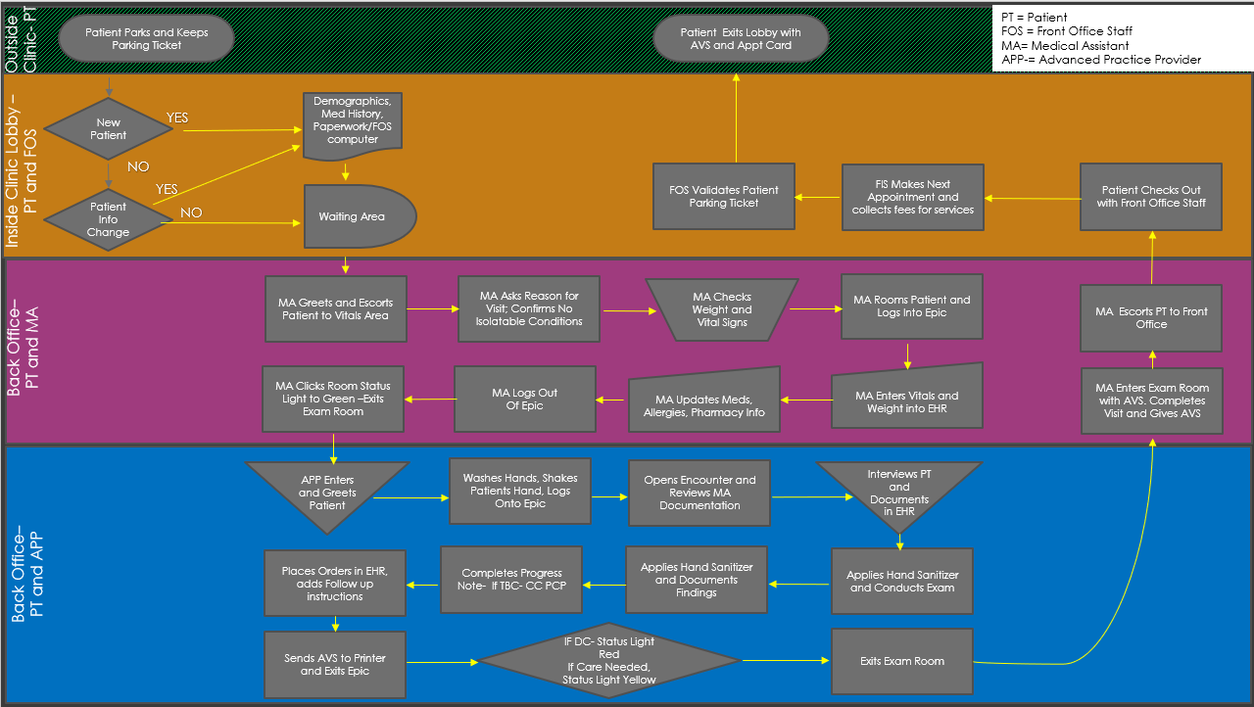

Appendix B
Future State Workflow

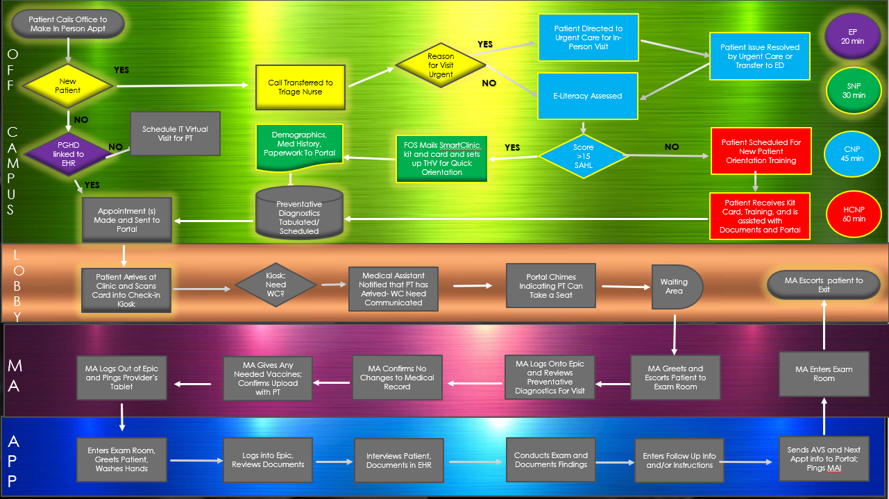

Appendix C
Ultra Future State Workflow
